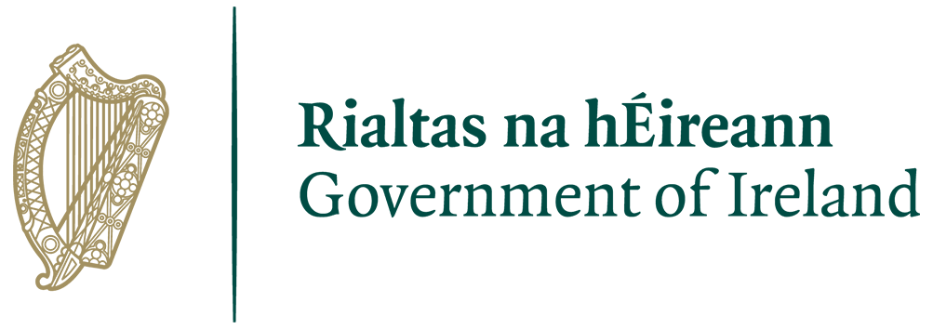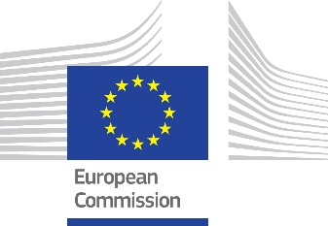

with co-sponsor

Dear all,

As joint cohort sponsors, Ireland and the European Commission last month officially launched the Cohort on Deliberative Democracy and Citizens’ Assemblies as part of the Summit for Democracy year of action. Only a few short weeks are left for you to commit to your selection of the model commitments (see annex) of the Summit for Democracy Cohort on Deliberative Democracy and Citizens Assemblies.

For democracy to remain strong, it has become increasingly important to integrate the people’s voice in new, safe and transparent ways into the process of policy-making in between elections. Citizens’ Assemblies provide an opportunity to create a diverse and inclusive deliberative public space with the objective of reaching collective recommendations from randomly-selected members of society whose paths rarely cross during their lifetimes. The collective character of the citizens’ input is also important in an increasingly individualised society.

We have chosen to sponsor this cohort as we've both delivered major engagements in challenging policy areas by deepening our deliberations with citizens. Using this method, we found it to be transformational. We want to share our story.

We are looking to gather a group of like-minded countries that are interested in taking these conversations across borders and sharing leadership on developing a framework for future cooperation.

We are now asking for expressions of interest in joining our efforts to work together and finding practical and innovative approaches to:

- Building a general understanding of successful projects in this field, including at national level on highly contentious issues;
- Supporting national governments who are interested in the possibilities to take the first step; and
- Creating connections so there are paths to ongoing communities of discussion.

The annex contains a range of model commitments on which Ireland, the European Commission and our specialist partners from across the world want to share with governments who are considering what commitments they want to make as part of the Summit.

Please note that you are not required to formally join the cohort, simply to support one (or a number) of the commitments or the declaration.

Please visit the Cohort website for further details, including footage of the official launch in January:
https://cop-demos.jrc.ec.europa.eu/summit-for-democracy

If you are interest in joining our efforts, participating in any way or have any questions, please get in touch with art.oleary@citizensassembly.ie or Iain.walker@newdemocracy.com.au

We very much look forward to hearing from you.

Signed

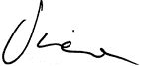

Dubravka Šuica
European Commission Vice-President for Democracy and Demography

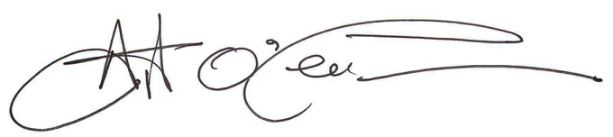

Art O’Leary
Chief Executive, Electoral Commission of Ireland

with co-sponsor

President Biden’s Summit for Democracy 2022
Deliberative Democracy & Citizens’ Assembly Cohort

Preamble
“Democracy doesn’t happen by accident. We have to renew it with each generation.”
President Biden at The Summit for Democracy Opening Session December 9, 2021

Many people legitimately feel like they do not have a voice, nor power, in shaping the decisions affecting their lives. Trust in experts has been declining, misinformation and disinformation are prevalent, and political polarisation – partly driven by electoral incentives – weakens our cohesiveness as societies.

Yet democracy has always been an idea larger than any one society and more than what happens at the ballot box. For people living under oppressive rule, it has been an idea and a hope that a better alternative awaits. With an endless bombardment of negativity, that light can only dim. The work of our group demonstrates that the democratic renewal of our generation is alive and well – embodied by Citizens’ Assemblies.

Citizens’ Assemblies bring together a group of people broadly representative of society, giving them the time and resources to grapple with complexity, learn from experts and stakeholders, listen to one another, and find common ground on challenging policy issues – an exercise in public judgment akin to a criminal jury, and in contrast to public opinion found through polling and surveys. There have now been hundreds of them around the world at all levels of government, tackling issues from abortion to climate change, infrastructure investment, and much more.

Citizens’ Assemblies do not just address the symptoms of democratic malaise, they get to the heart of the deeper, underlying drivers of it by making citizens truly central to our democracy. They recognise people’s agency, dignity, and political power. They do so in a way complementary to our existing institutions by strengthening societal cohesion, overcoming polarisation, and rebuilding public trust.

They are effective in building trust by including people who don’t tend to see themselves reflected in parliaments. They are effective at countering misinformation by giving people ample time to hear from and question diverse sources, including many of their own choosing. And polarization is reduced through the simple exercise of putting randomly chosen people in one room with a problem to solve and asking them to tell governments what they can agree on, and why.

This is not a concept, nor an academic idea. This has been run by the most senior leaders on the most vexing public issues. Our opportunity is to let people know that we have found a simple way to do democracy better, and let the message become one of strengthening, innovation and renewed trust and confidence in our free societies.

Citizens’ Assemblies and Citizen Deliberation

Shared International Commitments - Acting as a Global Community

A note on funding
We welcome the commitments of the Biden Administration through the President’s announcements in Warsaw, those of the European Commission’s European Democracy Action Plan, the concept of a NATO Democratic Resilience Centre, and the UN Democracy Fund’s existing global program.
The commitments which follow aim to allow national governments and partner NGOs to draw upon these funds to supplement their own where appropriate.

1. Commit to the 2022 Declaration on Deliberative Democracy and Citizens’ Assemblies.
Text attached at end of paper.
Milestone | Sponsoring governments to draft by Nov 3rd  Supporting governments to offer support prior to or during Summit.
Budget | n/a
Implementation assistance | Not required.

2. Create a Global ‘Marshall Plan for Democracy’ to empower countries with new or fragile democratic institutions by supporting and funding deliberative projects.

Priority will be given to Central and Eastern Europe given the emergency and threat to new democracies there.

Milestone | Expressions of interest from supranational funding organisations at the conclusion of the 2023 Summit.
Budget | Utilisation of existing funding for democracy budgets, with an allocation to be made specifically for these methods.
Implementation assistance | NGOs involved in process design and operation are available in 65 countries known to the cohort convenors. This means advice and turnkey operations (where desired) can be delivered in most locations.  Eastern Europe Working Group (~18 members) have an action plan ready to discuss with interested parties.  Participating governments are encouraged to contact the cohort organisers for direct assistance.

3. Support and advocate for the use of supranational democratic development funds being used for Citizens’ Assemblies as a highly promising means of countering polarisation, misinformation, and low public trust.

Milestone | Commitments from Participating Governments at 2023 Summit
Budget | Not required – commitment speaks to advocacy for allocation of existing democracy program budgets
Implementation assistance | Participating governments are encouraged to contact the cohort organisers for direct assistance with in-country partners as well as expert groups spanning multiple countries which draw on teams which have led icon projects around the world.

4. Support and participate in a Summit for Democracy Global Deliberaton on Democracy giving citizens a significant voice at this and future Summits.

Giving citizens an opportunity to assess the challenges facing democracy, learn about a wide range of democracy reforms and innovations, and find common ground on national and global solutions could potentially have a transformative impact.

Milestone | 1. Potential for Summit organisers to directly commission this in lead up to 2023 Summit.  2. Alternatively, can be delivered for participating governments who make this commitment in the 2023 Summit.
Budget | Approximately $250k - $2m per participating country.  May be covered by international/ supranational funding partner.
Implementation assistance | This working group includes process designers spanning most of the well known and influential projects in the field and we will draw on that pro bono internal capability.

5. Support an existing, trusted global institution, such as the OECD or UN Democracy Fund to act as a clearinghouse of project trials and their success, so nations have access to a global ‘What Works for Democracy’. The task would involve Assessment [Evidence], Advice and Advocacy with results available for all nations and their elected representatives.

Milestone | Commitment for funding support from Participating Governments by 2023 Summit.
Budget | 2 FTE staff for an initial 4 year commitment (Total: US$400k p.a.)
Implementation assistance | A number of cohort NGO partners produce ‘Learnings from’ documents and briefing notes on innovative projects. These are commonly produced as 3-4pg briefing notes designed for a senior decision maker.  The intent is to offer governments and sponsors a single location for clear guidance on elements of successful and unsuccessful democratic innovation projects.

National Commitments
Part A; Learning, Exploration & Committing to OECD Principles
Countries around the world have conducted hundreds of Citizens’ Assemblies. Their learnings have been documented in good practice principles by the OECD. The following national commitments are designed to help countries learn and adopt them.

6. Host an informational workshop for elected representatives to ensure they are informed on the array of democratic innovations which are proving effective, and to generate an understanding of the critical success factors for their use.
Workshops bring together international experts, public servants and legislators and are practically orientated to equip leaders to understand how projects operate.

Milestone | Allocation of responsibility to Minister and department.
Budget | ~US$40,000 plus travel expenses
Implementation assistance | Cohort members can provide a program of speakers spanning from designers & practitioners through to elected representatives who have major project experience.  Cohort NGOs can offer workshops with speakers on a turnkey basis.

7. Join a Senior Ministerial Co-ordination Group for bi-annual calls to remain informed on international major project experiences using Citizens’ Assemblies.

e.g. Ireland will conduct national Citizens’ Assemblies on Drug Use and also the Future of Education in 2023, and this forum will be where updates & learnings on this and similar projects can be shared with representatives from nations making this commitment.

Milestone | Participation in opening call October 2023
Budget | Negligible
Implementation assistance | Cohort organisers will provide the executive support to manage this program.

8. Commit to the principles and guidelines listed in the OECD ‘Deliberative Wave’ advice as representing a standard of quality for more meaningful community engagement.

Milestone | Allocation of responsibility to Minister and department.  Electronic distribution of OECD documents.
Budget | Negligible
Implementation assistance | OECD contact, and in-country NGO contacts.

9. Conduct a national-level Citizens’ Assembly.
Governments commit to identifying a challenging reform issue and commissioning a Citizens’ Assembly project on the topic. The project will include 50-100 citizens chosen in a Democratic Lottery being given an opportunity to freely respond to a tradeoff question with a self-written report.

Governments will commit to providing a substantive response to each recommendation within 90 days and at later moments when recommendations are turned into actual policy measures. These moments are clearly defined and communicated.

In keeping with the overarching goals of the summit, Democratic Innovation and Reform would be an appropriate topic for the Citizens' Assembly; the process could be complemented with other forms of public participation to elicit ideas and feedback from a larger number of citizens.

Milestone | Project announcement by PM or Minister.  Response by government or parliament.
Budget | In higher income countries US$300,000 per location – large geographies may require 6-8 locations.  In lower income countries projects can be operated for US$40,000- $70,000
Implementation assistance | Assistance with process design and implementation is available by contacting any cohort NGO.

Part B: Moving from Projects to Permanence

10. Establish a National Democracy Action Fund to be used for democratic innovation projects at regional and local levels where budgets are otherwise unavailable or insufficient.

Milestone | Commitment made at 2023 Summit.  Governance Minister to publicly announce size of fund.
Budget | A fixed percentage of the national election budget annually.
Implementation assistance | Assistance with process design and implementation is available by contacting any NGO in the cohort.

11. Create an ‘Office of Citizen Deliberation’ as an institution providing centralised and high-quality process design and operating capability across the public sector.

Milestone | This will generally be undertaken by national governments who have operated a successful national level project.  Initial milestone is an expression of interest to the cohort in designing an Office.
Budget | 6-8 staff (ongoing)
Implementation assistance | Assistance with process design and implementation is available by contacting any cohort NGO. The key design task here is noting the key tasks appropriate to this office for it to be successful

12. Institutionalise a formal structure for citizen deliberation within the parliamentary process. E.g. through integration with Committees

Milestone | Commitment made at 2023 Summit
Budget | 1. Initial advice and guidance can be done for minimal cost  2. an initial budget of US$500,000 for 2 years would be sufficient for elected representatives to gauge if this is complementary and beneficial to their work.
Implementation assistance | Assistance with process design and implementation is available by contacting any cohort NGO.

with co-sponsor

The Declaration of the Cohort for Deliberative Democracy and Citizens’ Assemblies.

We stand with the Summit for Democracy in launching its new Cohort for Deliberative Democracy and Citizens Assemblies.
Democracy is more than what happens at the ballot box. One stunning success story is the 600 citizens assemblies of recent years. They offer a proven and pioneering way to build on existing democracy and give it a sustainable future with citizens fully engaged. It is the start of a new era for democracy.
Citizens offering reasons, listening to the views of others, carefully weighing evidence then coming to considered, shared judgements is democracy at its best. Today, we need nothing less.
The fight against autocracy can only ever be fully won when citizens have a meaningful role in decisions taken by their governments. People who feel left behind need to become an active part of the democratic process.
Our democracies can move beyond stark binary choices and invite citizens to think and to listen. As signatories we commit to pursue this ideal of a deliberative democracy; one with mechanisms that work to unite rather than divide.
Building on the lessons from previous deliberations and citizens assemblies we will apply new approaches to do democracy better. A truly engaged citizenry will be our strongest asset.
Our aspiration is to renew trust and faith in our democracy. We intend to nurture that globally, nationally and in the heart of every citizen.
We pledge to do all in our power through the Summit for Democracy to ensure that democracy's best days lie ahead.

